The Ninth Wave
Student’s Name
Institution Affiliation
Course Number and Name
Instructor Name
Date

The Ninth Wave
Fashioned in 1850, the Ninth Wave is a Russian romantic oil painting created by Ivan Aivazovsky. The image is on canvas paintings with The State Russian Museum being its site of placement. The Ninth Wave is one of the masterpiece artistic works that gave Aivazovsky the international artist’s recognition (Aghasyan, 2017). The image below shows the artistic work by Aivazovsky.
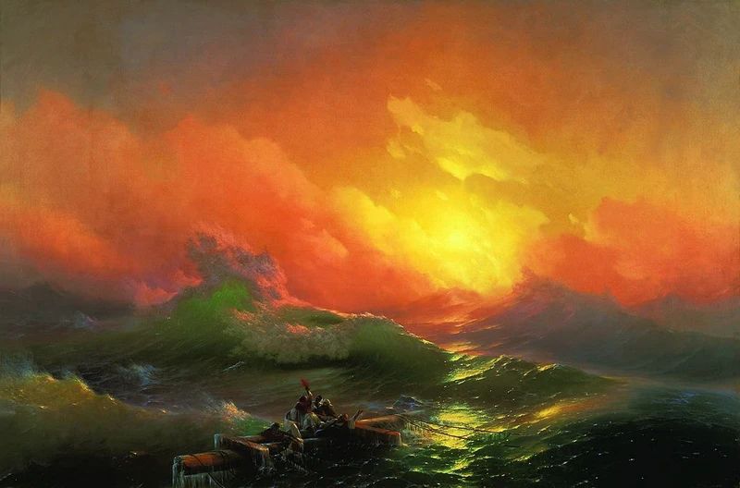
(Glioza, 2017)
Characteristics and Meaning of The Painting
Aivazovsky had typical love with the sea environment with the experience originating from his stay at the Black Sea seaside during his childhood. The power that the sea had mesmerized Aivazovsky through his childhood and painting career. This led to his reported courage development even at difficult times. The foundation of several paintings of Aivazovsky was from the experience that he had when the ship that they were in got caught by a storm. Every traveler felt dead through the storm till the ship's arrival at the port (Glioza, 2017). The classical masterpiece arts by Aivazovsky depicted shipwrecks and stiff storms that faced the vessels in the seas. Furthermore, the masterpiece art illustrated how nature was influential to the state of individuals that stayed desperate, lost, and helpless through the storm. Also, it shows how human beings have no strength to control the power of nature.
The Ninth Wave classical masterpiece in 1850 showed a different view by Aivazovsky on the power of nature. The piece of art displayed in figure one above shows some individuals who survived a shipwreck. There is an observable approaching 'ninth' massive wave appearing the individuals. Several legends state that the 'ninth wave' is dangerous and most substantial (Aghasyan, 2017). The individuals in the picture seem to hold on to a piece of mast. The name Ninth Wave is a dramatic name used for the painting. Also, the palette painting color and the atmosphere are optimistic. There is a visualization of sunrise upon the sea. The survivors have hope with the visualization of the dawn since the storm is almost over. The fame of Aivazovsky has been gained by these notional disparity paintings associated with the Ninth Wave classical masterpiece being exhibited in the Russian museum.

References
Aghasyan, А. (2017). Enchanted by the Sea: Ivan (Hovhannes) Aivazovsky. Բանբեր Հայագիտության= Вестник Арменоведения= Journal of Armenian Studies, 2, 121-139.
Glioza, O. (2017, December 24). A brief history of the 'Ninth wave.' Retrieved from https://theculturetrip.com/europe/russia/articles/a-brief-history-of-the-ninth-wave/

